**ASSIGNMENT 2**

**PHY1406 P-B FEBRUARY 2021 Marks 55**

**Question 1 (12 Marks)**

1. Figure 1 shows an instrument used to measure length.

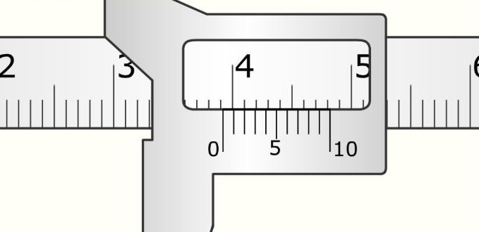

Figure 1: An instrument used to measure length

For the instrument shown in Figure 1, write:

* 1. its name; (1)
  2. the reading shown; (1)
  3. an example of a situation where the instrument may be used; and (1)
  4. **ONE** precaution that should be observed when using the instrument. (1)

1. A rectangular block measures 8 cm by 5 cm by 4 cm and has a mass of 1.2 kg.
2. If the gravitational field strength is 10N/kg, what is the weight of the block? (2)
3. What is the volume of the block? (3)
4. Calculate the density of the material from which the block is made. (2)
5. Mention one application of density. (1)

**Question 2 (13 Marks)**

1. A block of mass 72kg is raised to the top of a roof at a height of 20m. Take g = 10N/kg.
2. Calculate the potential energy of the block at the top of the roof. (3)
3. Calculate the kinetic energy as it fall at the of speed 6m/s. (3)
4. A boy uses the set up below to show how force (F) varies with the extension (e). 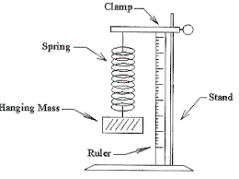

1. Define Hooke’s law. (2)
2. If a spring starts at a length of 13 cm, and it extends to a length of 21cm, what is the extension of the spring? (3)
3. A boy carried out the experiment above on how force varies with extension. If the boy obtains a straight line graph from the experiment, how would you describe the relationship between the force and extension? (2)

**Question 3 (10 marks)**

1. An electric bulb gives out light.
2. What is light? (1)
3. How is light produced in bulbs? (1)
4. A learner needs to buy an electric bulb to light up a room. The two bulbs, 100 W and 60 W bulbs are on sale and sold **for the same price** at the nearest café.

Figure 4: Two bulbs, a 60 W and a 100W found at the nearest café.

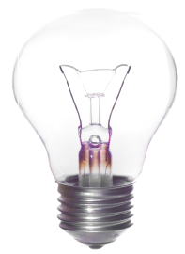

60W

100W

Use Figure 4 to answer the following questions.

1. Is light energy produced **per minute** by a 100W and a 60W bulb **equal**? Support your answer. (4,1)
2. Which bulb is more **powerful**? (1)
3. The learner can read clearly using any of the bulbs, which bulb would you recommend and why? (1,1)

**Question 4 [9 Marks]**

1. State the principle of moments. (2)
2. Figure 3 below shows a uniform beam supported at its center. The beam balances when force Y is placed 35cm from the center as shown.

Figure 3: A uniform beam supported at its centre.

35cm

10cm

35N

Y

1. Calculate the force Y on the beam. (3)
2. Mention two types of machines. (2)
3. Give one example of each machine mentioned. (2)

**Question 5 (11 Marks)**

Figure 7 shows a **coal**-powered station used to generate electricity for locals.

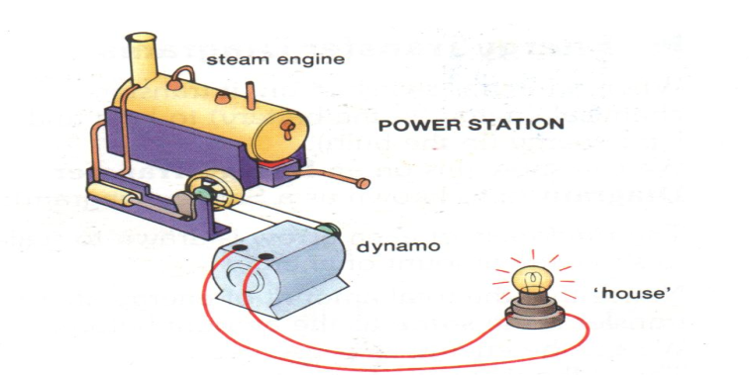

1. In which form is energy stored in coal? (1)
2. Is coal a renewable or non-renewable source of energy? (1)
3. Mention one example of a renewable source of energy. (1)
4. State the energy changes when burning coal. (2)
5. State **two** environmental problems caused by burning coal. (2)
6. Describe how the problems mentioned in (iv) above may be reduced. (2)
7. Give **two** advantage of a hydro-electric power station over a coal power station. (2)