**LESOTHO COLLEGE OF EDUCATION**



**UNIT 1: COORDINATION AND ITS IMPORTANCE**

**INTRODUCTION**

In this unit we are going to learn about the concept of coordination and its importance, parts of the nervous system, types of nerves and neurons, as well as the hormonal/endocrine system. We are going to work on the definition of the term coordination and how this process is important to our lives. We are also going to discuss the different parts of the nervous and endocrine systems in terms of their location and functions. We shall also look into a few examples of hormones and their effects.

**UNIT OBJECTIVES**

At the end of this unit, you should be able to:

* Describe coordination and its significance in living organisms.
* Describe the structure and function of the parts of the nervous system.
* Identify the two types of nerves.
* Describe the structure and function of the types of neurons.
* Define hormones.
* State examples of endocrine glands and their hormones.

**PRE-TEST**

Imagine that you are feeling hungry.

* What do your eyes do to help you to fulfill your hunger?
* What do your hands do to help you to fulfill your hunger?
* What do your legs do to help you to fulfill your hunger?
* Has it ever happened to you that one of your body parts refuses to cooperate when you are trying to fulfill your hunger?
* Use google search or your dictionary to check the meaning of the word coordinate and apply it to your body parts.
* Which part of the body do you think is responsible for coordinating the parts of the body?
* What do you think would happen to the body if its parts were not coordinated?

**COORDINATION**

**The nervous system**

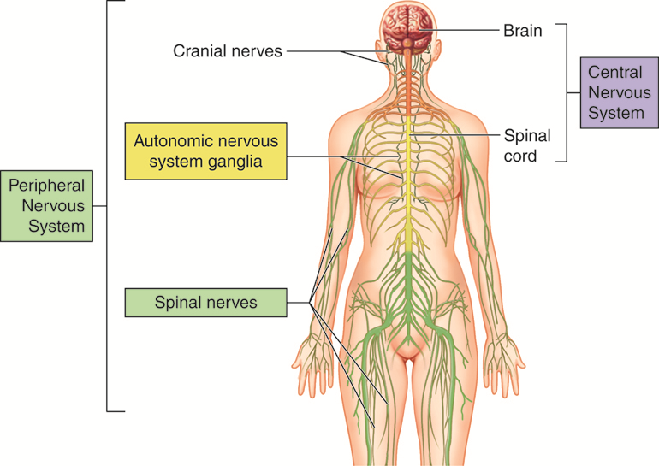

Figure 1: Parts of the nervous system

When you feel hungry the parts of the body are controlled in a way that allows them to work together to help you to respond to hunger. For instance, your eyes, nose, hands mouth, legs, etc, work together to respond to hunger. Hunger in this case is regarded as the **stimulus** and finding food is the **response**. The body has internal and external organs (sense organs) that receive the stimuli and these are called the **receptors**. The body also has organs which respond to stimuli, which are mainly the muscles and glands and these are called the **effectors**. It is important for the bodily functions to be coordinated such that the organs and systems of the body can work together in harmony to meet all the needs of the body to ensure survival, development, control and also to protect the body from harm.

The body is coordinated by two systems, namely, the **nervous system** and the **endocrine system**. The nervous system consists of the **brain, spinal cord and nerves**. The brain and the spinal cord form part of the so-called **central nervous system (CNS)** which controls all body functions. The **peripheral nervous system** **(PNS)** consists of nerves which convey nerve impulses in the form of electrochemical signals between the body and the central nervous system. The transmission of impulses in the body therefore follows a specific path called the **neural/nervous pathway** which can be represented as follows:



*Structure and fuction of the brain*

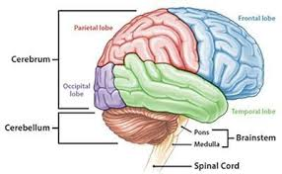

Figure 2: Parts of the brain

The main function of the brain is to control all voluntary actions, non-reflex involuntary/automatic actions and reflex actions of the body parts found on the head area. Voluntary actions are the activities which are consciously performed in the body and they are controlled in the **cerebrum** and **cerebellum** of the brain. Examples of actions controlled by the cerebrum include sensation, thinking, decision making, intelligence, memory, movement, etc. Actions controlled by the cerebellum include movement, posture and balance. **Medulla oblongata** is the part of the brain responsible for automatic actions such as heart beat, breathing, exretion, respiration, etc, and the reflex actions such as the reflex of the eye in response to light.

*Functions of the spinal cord*

The main function of the spinal cord is to pass impulses between the brain and the spinal nerves. It also acts as a coordinator for reflexes of the body parts found below the neck area.

*Reflex actions*

These are the automatic/involuntary rapid reactions of the body towards stimulus that has the potential to harm the body. Reflex actions are the only responses which are capable of happening quickly even before the impulse reaches the brain. These reactions follow a nervous pathway called a **reflex arc**.

Examples:

* Knee jerk:



* Eye reflex in response to light

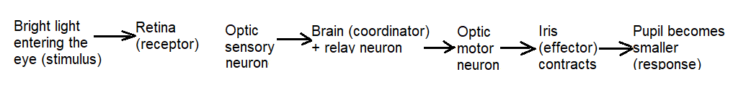

**Types of nerves**

Nerves are tissues which carry impuses between the central nervous system and the rest of the body. Each nerve is a bundle of many long nerve cells (neurons) which are specialised for impulse conduction. There are two types of nerves as follows;

* **cranial nerves** which carry impulses between parts on the head and the brain, and
* **spinal nerves** which carry impulses between parts of the body below the neck area and the spinal cord.

**Types of neurons**

There are three types of neurons as follows;

* **Sensory neurons** carry impulses from the receptors (sense organs) and the CNS.
* **Relay/intermediate neurons/interneurons** carry impulses from one neuron to another inside the CNS.
* **Motor neurons** carry impulses from the CNS to the effectors (muscles and glands).

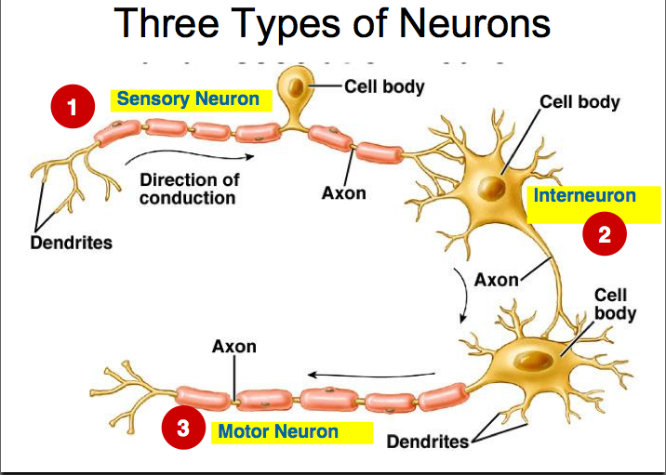

Figure 3: Types of neurons

**The endocrine system**

This is a system of internal glands which secrete hormones to change the function of one or more target organs. Hormones are chemical substances which are produced by ductless glands, carried by blood to change the function of one or more target organs, after which they are destroyed by the liver. Examples of hormones include adrenaline, insulin, glucagon, oestrogen, progesterone, testosterone, luteinising hormone, follicle-stimulating hormone, etc.

|  |  |  |
| --- | --- | --- |
| **Hormone** | **Gland** | **Effects** |
| Adrenaline | Adrenal glands | * Increased heart beat * Increased blood pressure * Increasing lung capacity and breathing rate * Enlarged pupils * Constriction of skin arterioles and dilation of muscle arterioles * Etc. |
| Insulin | Pancreas | * Reduction of blood sugar level by converting glucose (blood sugar) into glycogen (storage form of carbohydrates) to be stored in the liver and muscles. |
| Glucagon | Pancreas | * Increment of blood sugar level by converting stored glycogen into glucose which can be used for respiration. |

**UNIT SUMMARY**

In this unit we have learned that the bodily functions are coordinated through the nervous system and the endocrine system. The central nervous system interpretes impulses and sends out responses accordingly. The nerves conduct impulses around the body. The hormones are carried in blood because the parts that they affect are far from the glands which produce them and there is no connective tube/duct between the gland and its target organ.

**POST-TEST 1**

1. Describe the functions of brain, spinal cord and nerves.
2. Name the two types of nervous systems and state the main parts of each system.
3. Name the two types of nerves.

* To which organ is each type of nerve connected?
* Suggest a function of each type of nerve.

1. Name the three types of neurons and state the function and location of each type of neuron.
2. Describe the endocrine system.
3. Give three examples of endocrine glands.
4. Define the term 'hormone'.
5. State the names of the endocrine glands which produce the following hormones; adrenaline, insulin, glucagon, stating clearly where each gland is found in the body.

**FURTHER READING**

Beckett, B. & Gallagher, R. 2001. *New coordinated science: Biology for higher tier.* New York: Oxford University Press.

Taylor, D. J., Green, N. P. O. & Stout, G. W. 1997. Biological science. Cape Town: Cambridge University Press.